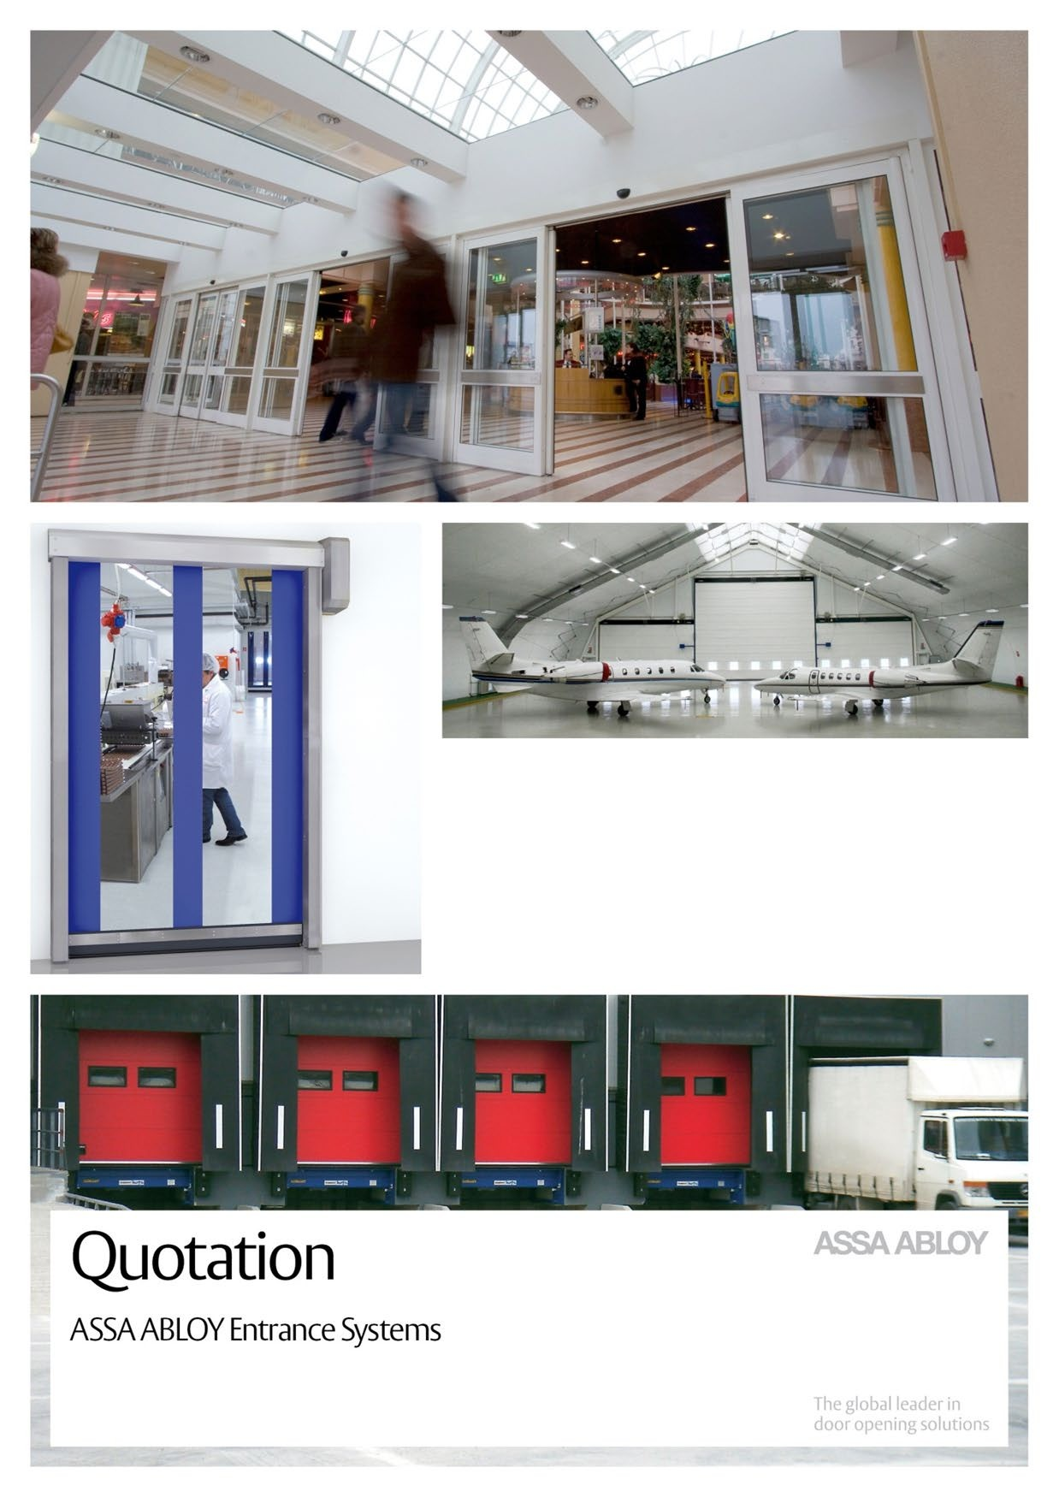
GMR Aero TechnicASER SUPPLIER

ASSA ABLOY Entrance Systems VAT: SE-55605995230
Production Skellefteå AB BANK: SEB, (Skandinaviska Enskilda Banken)
PO Box 383 Swift: ESSESESS
SE-931 24 SKELLEFTEÅ Account EUR 5746-82 517 89
Sweden IBAN: SE04 5000 0000 0574 6825 1789
www.assaabloyentrance.com

GMR Aero Technic Hangars 221129 Rev-0
Hyderabad, India

Page 2 / 5

NIHVA Technologies Pvt Ltd Pune, India
Vijay Tarak
E-mail: sales@nihva.com Phone: +91-8551093333

QUOTATION
Dear Vijay
With reference to our recent discussions, we have the pleasure to offer you the following solution.

ASSA ABLOY VL3190 Megadoor with following clear opening:
- 84000 x 23000/14000, (CWxCH) clear opening.
- 99000 x 14000, (CWxCH) clear opening.
For detailed description please see Appendix 1-3.
The scope includes design, production, delivery of door as described in the attached technical specification.
For detailed scope please see Appendix 1.
A suitable structure should be available designed in accordance with final approval drawings issued by ASSA ABLOY.
Tolerances/deflections of the support structure to be in accordance with these drawings.

Number of doors: 2
- 84000 x 23000/14000, (CWxCH). Unit rate: USD $614,300
- 99000 x 14000 mm (CWxCH) Unit rate: USD $679,000 Total price for two doors: US Dollar $1,293,300

ASSA ABLOY Entrance Systems VAT: SE-55605995230
Production Skellefteå AB BANK: SEB, (Skandinaviska Enskilda Banken)
PO Box 383 Swift: ESSESESS
SE-931 24 SKELLEFTEÅ Account EUR 5746-82 517 89
Sweden IBAN: SE04 5000 0000 0574 6825 1789
www.assaabloyentrance.com

Notes:
- The doors are designed for a wind load of 1.2 kPa
- Freight costs included.
- Supervisor excluded.
- Installation team excluded.
- Equipment, crane, sky lift, etc. Excluded.
- Cables Included.
- Cable trays Excluded.
- Power supply to main control box excluded.

Terms of payment:
Payment will be paid over a tenure of 5 years on half yearly basis with additional interest and insurance cost as below:
Payment plan 5 year | Month
Contract value | $1,293,300
Insurance | $47,852 | Category D | 3.70%
Interest / fee | $51,732 |  | 4.00%
Total Amount with Interest and Insurance | $1,392,884
No of payments | 10
Period Payment (Half Yearly) | $139,288
Issue of the first invoice: After the completion of delivery. Payment to be made within 30 days of issuing of invoice.

Time of delivery
Supplier provides design specification of the door system within 2 weeks from the receipt of the Purchaser’s final specification.
Fabrication will not start until we have received full and final approval.
Supplier to manufacture the door system within 10-12 weeks from the date on which the Purchaser has confirmed the Supplier’s design specification in writing. Should the Purchaser not confirm the design specification, the Supplier shall have no remaining obligations under this quotation.
Freight: 6-8 weeks.
Delivery times mentioned herein are based on current situation and is therefore expected but not guaranteed.
Intermediate sales, holidays, seasonality, and other circumstances may impact delivery time. Please make sure to re-confirm delivery time with us when the project time plan is available.

Terms of delivery
CIF Mumbai (Incoterms 2010)

Warranty period: 2 Years
If a defect arises within the warranty period stated, which is attributable to faulty design, materials the product will be repaired at our discretion without charge. This guarantee is subject to proper use

of the product and assumes that the product is regularly serviced and maintained by skilled personnel in accordance with the operation and maintenance instructions supplied.

Service
We would suggest that you take advantage of a service and maintenance contract on the ASSA ABLOY Entrance Systems products, which will guarantee trouble free operation and speed of response in an emergency.

General conditions
Orgalime S 2012 General Conditions for the Supply of Mechanical, Electrical and Electronic Products shall apply to this quotation and any subsequent sales made by the Supplier. Copy available on request.
In case of any additional, contradictory, or different terms submitted by the Purchaser, the terms of this quotation including its appendices and Orgalime shall prevail unless otherwise has been agreed in writing.
In case of conflict between this quotation including its appendices and Orgalime this quotation including its appendices shall prevail.
No order by the Purchaser based on this quotation is accepted by the Supplier until the Supplier has performed its customary credit check of the Purchaser with a satisfactory outcome.
This quotation shall be valid to 25/07/2021.

Appendices
- Appendix 1- Technical data & Scope details
- Appendix 2- Specific installation conditions
- Appendix 3- Load Diagram
We hope that this quotation is in line with your expectations and look forward to receiving your order. Should you require any further information or assistance, please do not hesitate to contact us.
Yours faithfully
Ashish Nair
ASSA ABLOY Entrance Systems AB Hangar & Large Application Doors Mobile: +971 50 6320495
Office: +971 4 88 52888

Quote acceptance
To allow us to proceed with this work, please complete the details below and return to E-mail: ashish.achuthan@assaabloy.com

Company name: NIHVA Technology Pvt Ltd.

GST number: 27AAECN0437H1ZM

Contract value: USD 1,293,300

Invoice address and e-mail:

Site address:

Order number:

Name:

Phone:

E-mail:

Date:

Signed by authorized Purchaser:

Printed name:

